Engineered wood includes a range of derivative wood products which are manufactured by binding or fixing the strands, particles, fibers, or veneers or boards of wood, together with adhesives, or other methods of fixation to form composite materials. The products can be used for joists and beams that replace steel in many building projects.
Typically, engineered wood products are made from the same hardwood and softwoods used to manufacture lumber. Sawmill scraps and other wood waste can be used for engineered wood composed of wood particles or fibers, but whole logs are usually used for veneers, such as plywood, MDF, or particle board.
Plywood, a wood structural panel, is sometimes called the original engineered wood product. Plywood is manufactured from sheets of cross-laminated veneer and bonded under heat and pressure with durable, moisture-resistant adhesives. By alternating the grain direction of the veneers from layer to layer, or “cross-orienting”, panel strength and stiffness in both directions are maximized. (Plywood layers (called veneers or plies) are glued together, with adjacent plies having their wood grain rotated relative to adjacent layers up to 90 degrees).
This alternation of the grain is called cross-graining and has several important benefits: it reduces the tendency of wood to split when nailed at the edges; it reduces expansion and shrinkage, providing improved dimensional stability; and it makes the strength of the panel consistent across all directions. There are usually an odd number of plies, so that the sheet is balanced—this reduces warping. Because plywood is bonded with grains running against one another and with an odd number of composite parts, it is very hard to bend it perpendicular to the grain direction of the surface ply.
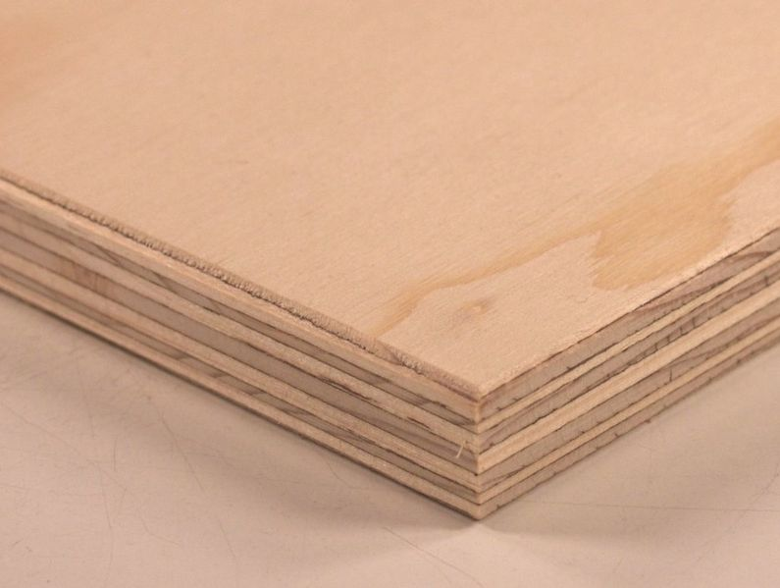

Pg. 1
Oriented Strand Board (OSB) is an engineered wood particle board formed by layering strands (flakes) of wood in specific orientations. OSB is a material with high mechanical properties that make it particularly suitable for load-bearing applications in construction.
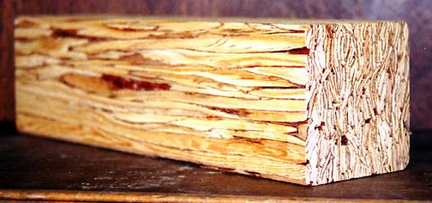

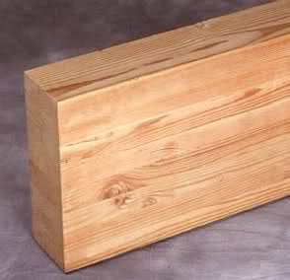
Parallel Strand Lumber (PSL) consists of long veneer strands laid in parallel formation and bonded together with an adhesive to form the finished structural section. A strong, consistent material, it has a high load carrying ability and is resistant to seasoning stresses so it is well suited for use as beams and columns for post and beam construction, and for beams, headers, and lintels for light framing construction.

Pg. 2

Particleboard or Chipboard is manufactured by mixing wood particles or flakes together with a resin and forming the mixture into a sheet. The raw material to be used for the particles is fed into a disc chipper with between four and sixteen radially arranged blades. The particles are first dried, after which any oversized or undersized particles are screened out. Resin, in liquid form, is then sprayed through nozzles onto the particles. There are several types of resins that are commonly used. Amino, formaldehyde based resins are the best performing when considering cost and ease of use. Particleboard is cheaper, denser, and more uniform than conventional wood and plywood and is substituted for them when appearance and strength are less important than cost. However, particleboard can be made more attractive by painting or the use of wood veneers onto surfaces that will be visible. Though it is denser than conventional wood, it is the lightest and weakest type of fiberboard, except for insulation board.
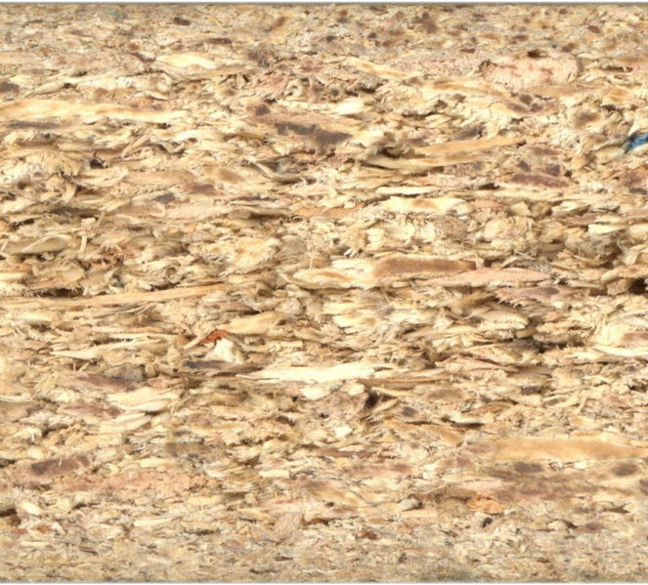
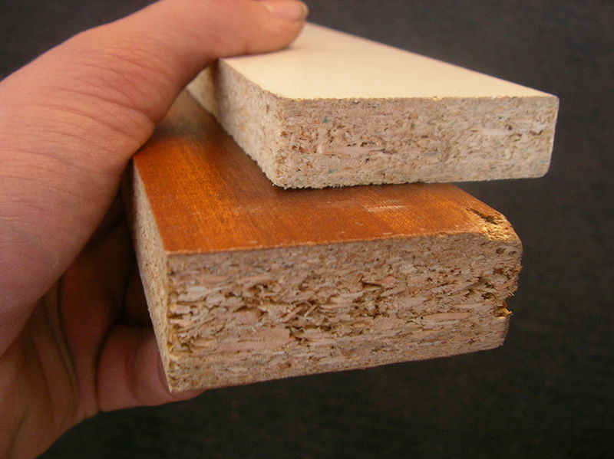

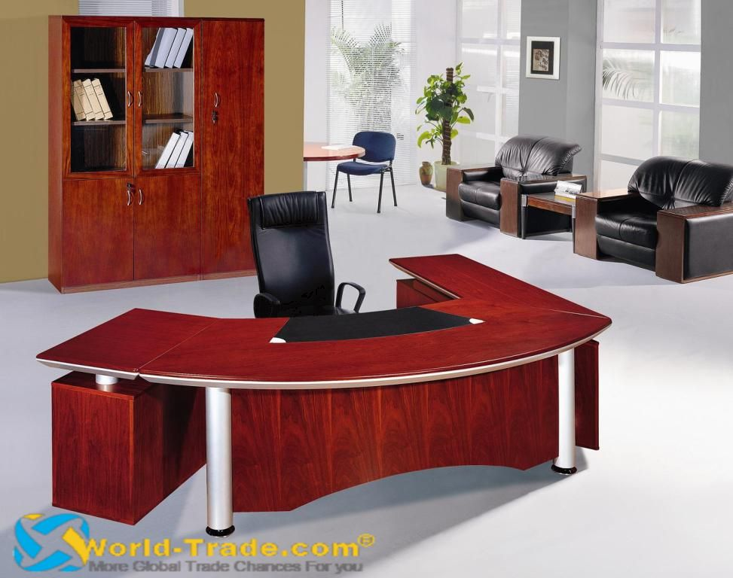
Veneer refers to thin slices of wood, usually thinner than 3 mm (1/8 inch), that typically are glued onto core panels (typically, particle board or MDF) to produce flat panels such as doors, tops and panels for cabinets and parts of furniture. Veneer is obtained either by "peeling" the trunk of a tree or by slicing large rectangular blocks of wood known as flitches. The appearance of the grain and figure in wood comes from slicing through the growth rings of a tree and depends upon the angle at which the wood is sliced.
Furniture made with wood veneer uses less wood than the same piece of furniture made with solid wood. Some projects built using wood veneer would not be possible to construct using solid lumber, owing to expansion and contraction caused by fluctuation of temperature and humidity. Pg. 3
Medium-Density Fiberboard (MDF) is an engineered wood product made by breaking down hardwood or softwood residuals into wood fibers, often in a defibrator, combining it with wax and a resin binder, and forming panels by applying high temperature and pressure. MDF is generally denser than plywood. It is made up of separated fibers, but can be used as a building material similar in application to plywood. It is stronger and much denser than particle board.
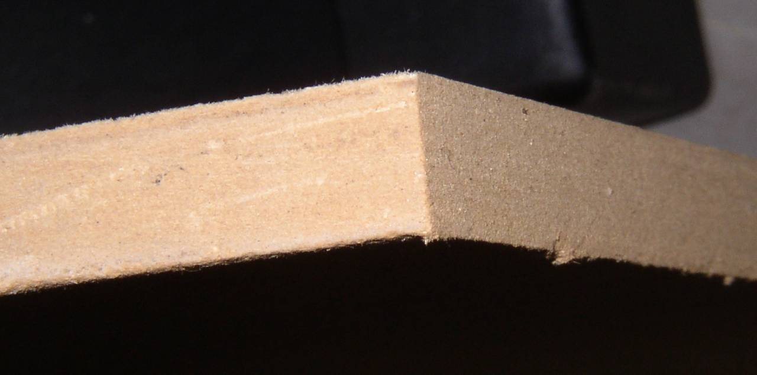

Pg. 4

