**Sheet Metal** is metal formed by an industrial process into thin, flat pieces. Sheet metal is available in flat pieces or coiled strips. Thickness of sheet metal is commonly specified by a traditional, non-linear measure known as its gauge. The larger the gauge number, the thinner the metal. There are many different metals that can be made into sheet metal, such as aluminum, brass, copper, steel, tin, nickel, and titanium.

Aluminum is a popular metal used in sheet metal due to its flexibility and cost effectiveness. The four most common grades available as sheet metal are 1100-H14, 3003-H14, 5052-H32, and 6061-T6.

***Cutting***

[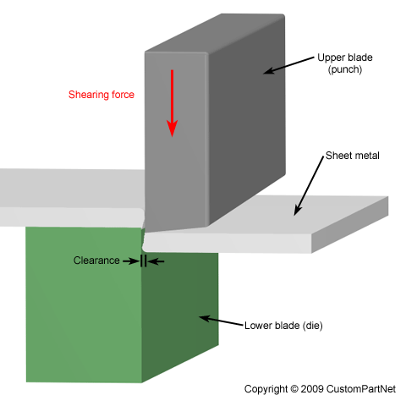](http://www.custompartnet.com/wu/images/sheet-metal/shearing.png)A variety of cutting processes that utilize shearing forces exist to separate or remove material from a piece of sheet metal stock in different ways. Each process is capable of forming a specific type of cut, some with an open path to separate a portion of material and some with a closed path to cutout and remove that material. By using many of these processes together, sheet metal parts can be fabricated with cutouts and profiles of any 2D geometry. Such cutting processes include the following:

**Shearing** - Separating material into two parts.

**Blanking** - Removing material to use for parts.

**Punching** - Removing material as scrap.

[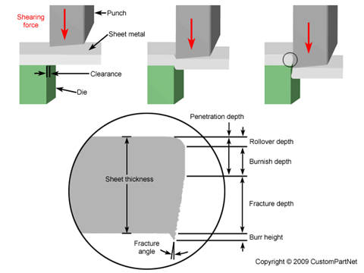](http://www.custompartnet.com/wu/images/sheet-metal/shearing-edge.png)A typical **shear** machine includes a table with support arms to hold the sheet, stops or guides to secure the sheet, upper and lower straight-edge blades, and a gauging device to precisely position the sheet. The sheet is placed between the upper and lower blade, which are then forced together against the sheet, cutting the material. In most devices, the lower blade remains stationary while the upper blade is forced downward.

The effects of shearing on the material change as the cut progresses and are visible on the edge of the sheared material. When the punch or blade impacts the sheet, the clearance between the tools allows the sheet to plastically deform and "rollover" the edge. As the tool penetrates the sheet further, the shearing results in a vertical burnished zone of material. Finally, the shear stress is too great and the material fractures at an angle with a small burr formed at the edge. Pg. 1

[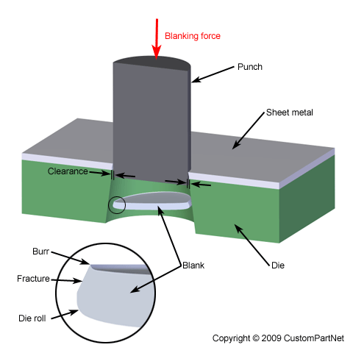](http://www.custompartnet.com/wu/images/sheet-metal/blanking.png)**Blanking** is a cutting process in which a piece of sheet metal is removed from a larger piece of sheet metal stock by applying a great enough shearing force. In this process, the piece removed, called the blank, is not scrap but rather the desired part. Blanking can be used to cutout parts in almost any 2D shape, but is most commonly used to cut work-pieces with simple geometries that will be further shaped in subsequent processes. Final parts that are produced using blanking include gears, jewelry, and watch or clock components.

[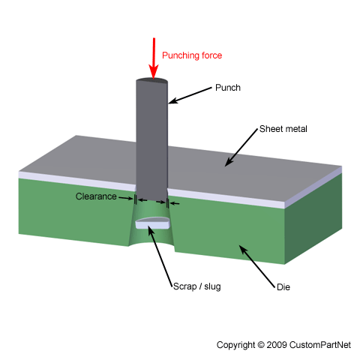](http://www.custompartnet.com/wu/images/sheet-metal/punching.png)The blanking process requires a blanking press, sheet metal stock, blanking punch, and blanking die. The sheet metal stock is placed over the die in the blanking press. The die, instead of having a cavity, has a cutout in the shape of the desired part and must be custom made unless a standard shape is being formed. Above the sheet, resides the blanking punch which is a tool in the shape of the desired part. Both the die and punch are typically made from tool steel or carbide. The hydraulic press drives the punch downward at high speed into the sheet. A small clearance, typically 10-20% of the material thickness, exists between the punch and die. When the punch impacts the sheet, the metal in this clearance quickly bends and then fractures. The blank which has been sheared from the stock now falls freely into the gap in the die. This process is extremely fast, with some blanking presses capable of performing over 1000 strokes per minute.

**Punching** is a cutting process in which material is removed from a piece of sheet metal by applying a great enough shearing force. Punching is very similar to blanking except that the removed material, called the slug, is scrap and leaves behind the desired internal feature in the sheet, such as a hole or slot. The most common punched holes are simple geometric shapes (circle, square, rectangle, etc.) or combinations thereof. The slug that is punched out of the sheet falls freely through the tapered opening in the die.

Pg. 2

***Bending***

[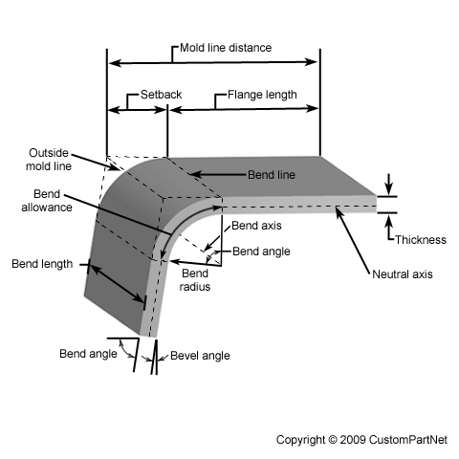](http://www.custompartnet.com/wu/images/sheet-metal/bending-diagram.png)Sheet metal forming processes are those in which force is applied to a piece of sheet metal to modify its geometry rather than remove any material. The applied force stresses the metal beyond its yield strength, causing the material to plastically deform, but not to fail. By doing so, the sheet can be bent or stretched into a variety of complex shapes. Sheet metal forming processes include the following:

Deep Drawing

Roll Forming

Spinning

Bending

Bending is a metal forming process in which a force is applied to a piece of sheet metal, causing it to bend at an angle and form the desired shape. A bending operation causes deformation along one axis, but a sequence of several different operations can be performed to create a complex part. Bent parts can be quite small, such as a bracket, or up to 20 feet in length, such as a large enclosure or chassis. A bend can be characterized by several different parameters, shown in the image below.

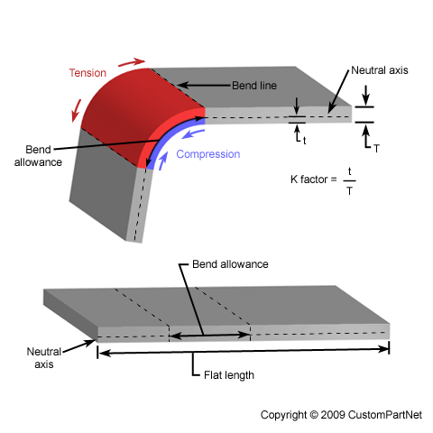

The act of bending results in both tension and compression in the sheet metal. The outside portion of the sheet will undergo tension and stretch to a greater length, while the inside portion experiences compression and shortens. The neutral axis is the boundary line inside the sheet metal, along which no tension or compression forces are present. As a result, the length of this axis remains constant. The changes in length to the outside and inside surfaces can be related to the original flat length by two parameters, the bend allowance and bend deduction, which are defined below.

Pg. 3

[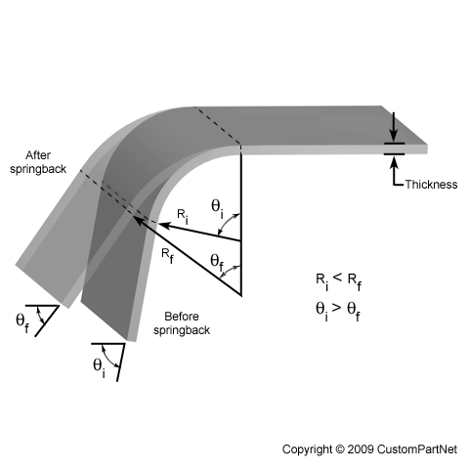](http://www.custompartnet.com/wu/images/sheet-metal/bending-springback.png)When bending a piece of sheet metal, the residual stresses in the material will cause the sheet to springback slightly after the bending operation. Due to this elastic recovery, it is necessary to over-bend the sheet a precise amount to achieve the desired bend radius and bend angle. The final bend radius will be greater than initially formed and the final bend angle will be smaller. The ratio of the final bend angle to the initial bend angle is defined as the springback factor, KS. The amount of springback depends upon several factors, including the material, bending operation, and the initial bend angle and bend radius.

[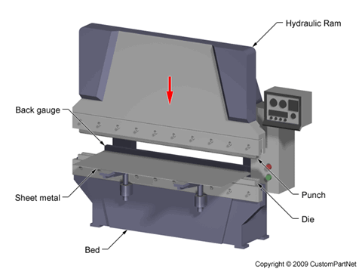](http://www.custompartnet.com/wu/images/sheet-metal/press-brake.png)

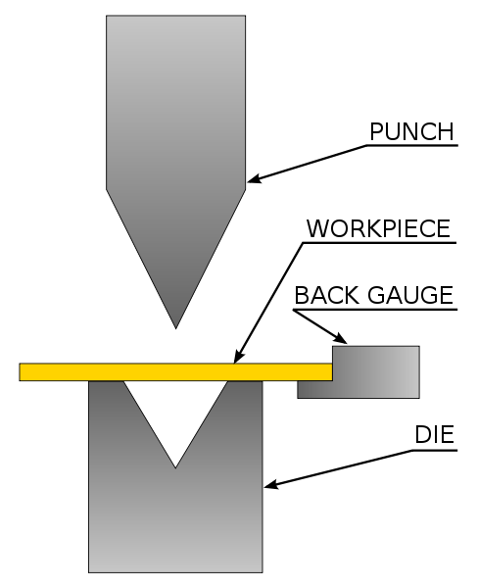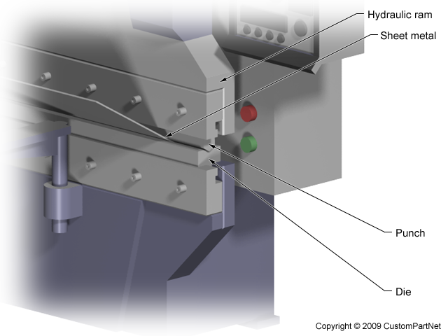Bending is typically performed on a machine called a press brake, which can be manually or automatically operated. For this reason, the bending process is sometimes referred to as press brake forming. Press brakes are available in a range of sizes (commonly 20-200 tons) in order to best suit the given application. A press brake contains an upper tool called the punch and a lower tool called the die, between which the sheet metal is located. The sheet is carefully positioned over the die and held in place by the back gauge while the punch lowers and forces the sheet to bend. In an automatic machine, the punch is forced into the sheet under the power of a hydraulic ram. The bend angle achieved is determined by the depth to which the punch forces the sheet into the die. This depth is precisely controlled to achieve the desired bend.

**Press Brake (Closed) Pg. 4**

***Drawing***

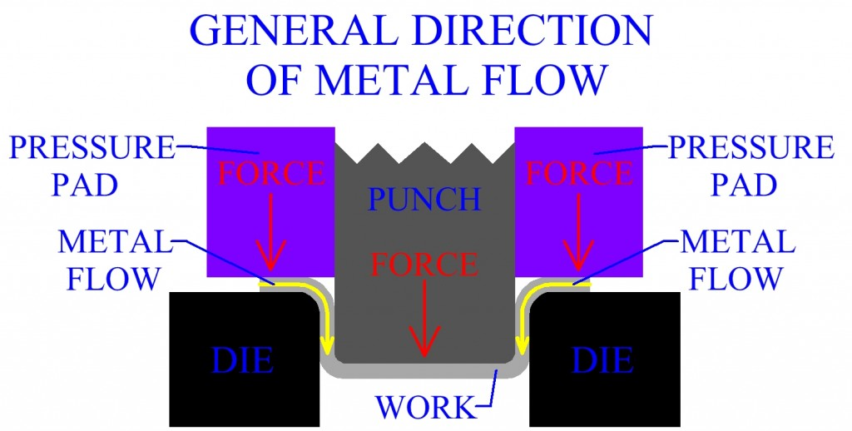**Drawing** is a metalworking process which uses tensile forces to stretch metal. The specific definition for sheet metal drawing is that it involves plastic deformation over a curved axis. The success of forming is in relation to two things, the flow and stretch of material. As a die forms a shape from a flat sheet of metal, there is a need for the material to move into the shape of the die. The flow of material is controlled through pressure applied to the blank and lubrication applied to the die or the blank. If the form moves too easily, wrinkles will occur in the part. To correct this, more pressure or less lubrication is applied to the blank to limit the flow of material and cause the material to stretch or thin. If too much pressure is applied, the part will become too thin and break. Drawing metal is the science of finding the correct balance between wrinkles and breaking to achieve a successful part.

DIE DIE

If required percent reduction of sheet metal is over 50%, the part must be formed in multiple operations. Redrawing is the subsequent deep drawing of a work that has already undergone a deep drawing process. By using more than one operation, a greater magnitude of deep drawing can be accomplished.

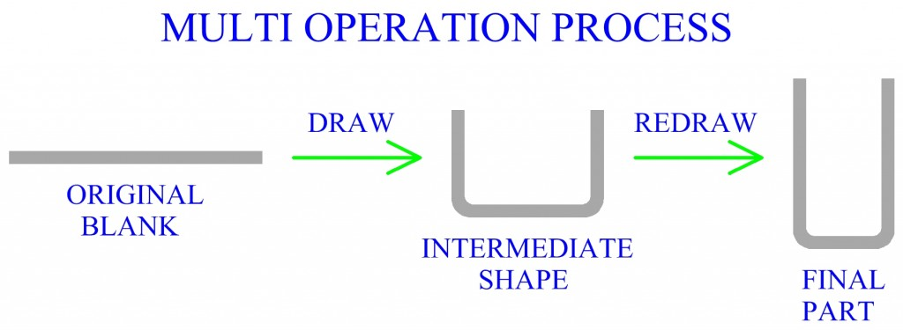

Pg. 5

**Sheet Metal (Wakil)**

**>> Thin walls compared to surface area.**

**>> Worked in cold state unless thick sheets (1/4”)**

**Operation Groups:**

**1) Cutting**

**Shearing (Straight line)**

**Blanking (Closed contour)**

**Cutoff (Open curve)**

**Note: Punching >> slug is scrap**

**Blanking >> slug is the part**

**Forces Required:**

**Basically: Shear Strength * Area being sheared = Force**

**Blanking Force (cutting) = K * P * t * τultimate**

**P = perimeter**

**t = thickness**

**τultimate = ultimate shear strength (Handbooks)**

**K =1.3 (stress state to pure shear factor) [0 soft to 2.6hard]**

**Al = 1.3**

**Example: Estimate the force needed to punch a 1” diameter hole through 1/8” titanium alloy where k =0.70.**

**Force=KtP τultimate= (.7)(1/8)π(1)(140,000) = 38,500 lbs.**

**Note: Friction can change the final answer**

**2) Shape-Forming**

**>Bending, drawing (cup like products), stretch-forming**

**Compression (Inside Radius)**

**Tension (Outside Radius)**

**Neutral Plane**

**Springback: elastic recovery after load is removed.**

Pg. 6