ISE 261 HOMEWORK TWO Due Date: Tuesday 6/03
1. An electrical engineer has on hand two boxes of resistors, with five resistors in each box. The resistors in the first box are labeled 10 ohms, but in fact their resistances are 9, 10, 11, 12, and 13 ohms. The resistors in the second box are labeled 20 ohms, but in fact their resistances are 18, 19, 20, 21, and 22 ohms. The EE chooses one resistor from each box and determines the resistance of each. Let A be the event that the first resistor has a resistance greater than 11, let B be the event that the second resistor has a resistance less than 20, and let C be the event that the sum of the resistances is equal to 30. List the sample space for this experiment, and specify the subsets corresponding to the events A, B, and C.
Ans:

2. Aluminum usage in automobiles has been climbing steadily. As recently as 1990, there were no aluminum-structured passenger cars in production anywhere in the world, but by 1997, there were seven of them, including the Audi A8. With weight savings of up to 47% over steel vehicles, such cars use less fuel, create less pollution, and are recyclable. Aluminum pistons are also used in automotive internal combustion engines. Aluminum pistons are manufactured through casting because of its capability to produce near-net shaped parts at the required production rates. However, with poorly designed molds, under-fills or excess porosity can cause parts to be rejected. In a process that manufactures certain aluminum pistons, the probability that a piston has an under-fill defect is 0.05, the probability that a piston has a porosity defect is 0.04, and the probability that a piston has both defects is 0.01. What is the probability that a randomly chosen piston has a defect?
Ans:

3. In Problem #2, what is the probability that a random piston has no defect?
Ans:
4. In Problem #2, what is the probability that a random piston has a porosity defect but no under-fill defect? (Drawing a Venn diagram may help).
Ans:

5. In Problem #2, what is the probability that the random piston will have an under-fill defect, given that it has a porosity defect?
Ans:

6. Customers who purchase an aluminum-structured Audi A8 can order an engine in any of three sizes: 2.0L, 2.4L, and 2.8L. Of all Audi A8 cars sold, 45% have the 2.0L engine, 35% have the 2.4L, and 20% have the 2.8L. Of cars with the 2.0L engine, 10% have been found to fail an emissions test within four years of purchase, while 12% of those with the 2.4L engine and 15% of those with the 2.8L engine fail the emissions test within four years. An Audi A8 record for a failed emissions test taken within four years of purchase is chosen at random. What is the probability that it is for an Audi A8 car with a 2.8L engine?
Ans:

7. A CMOS module of a computer system contains three electrical components, A, B, and C. All three components must function for the CMOS module of the computer system to work properly. The probability that component A fails is 0.0015, the probability that component B fails is 0.0005, while the probability that component C fails is 0.0001. Assuming the three components function independently, what is the probability that the CMOS module of the computer system functions?
Ans:

8. As an extreme weather adjustment, an electrical supply company provides a lower supply rate to households that use less than 500 kwh per month during summer months. Let J denote the event that a household gets the low rate in July, and let A denote the event that the same household gets the low rate in August.
Suppose P(J) = 0.20, P(A) = 0.22, and P(J ∩ A) = 0.10. What is the probability that the household gets the low rate in either July, August, or both?
Ans:

9. For problem #8, find the probability that the household gets the low rate in neither July nor August.
Ans:

10. For problem #8, find the probability that the household gets the low rate in July but not in August.
Ans:

11. During the spring semester, "many" years ago, 300 SUNY engineering students enrolled in both Calculus II and Physics I. Of these students, 90 earned an A in calculus, 66 earned an A in physics, and 45 “mystically” received an A in both calculus and physics. What is the probability that a randomly chosen student earned an A in at least one of the two courses?
Ans:

12. In problem #11, what is the probability that a randomly chosen student got an A in calculus but not in physics?
Ans:

13. Four Watson engineering students stand in line at a movie theater to see The Truth About An Inconvenient Truth. Into how many different ways can the students be arranged?
Ans:

14. Six lifeguards are available for duty one afternoon. There are five lifeguard stations. In how many ways can five lifeguards be chosen for the stations?
Ans:

15. A die is rolled 12 times. Given that two of the rolls came up 1, four came up 2, three came up 3, one came up 4, two came up 5, and none came up 6, how many different arrangements of the outcomes are there?
Ans:

16. A box of bolts contains 9 thick bolts, 8 medium bolts, and 4 thin bolts. A box of nuts contains 5 that fit the thick bolts, 3 that fit the medium bolts, and 2 that fit the thin bolts. One bolt and one nut are chosen at random. What is the probability that the nut fits the bolt?
Ans:

17. An ISE 261 test consists of 12 questions. Six are True-False questions, and Six are multiple-choice questions that have five choices each. A student must select an answer for each question. In how many ways can this be done?
Ans:

18. A simplified production method used in the manufacture of aluminum cans is depicted in the schematic diagram shown below. The initial input into the process consists of coiled aluminum sheets. In a process known as cupping these sheets are uncoiled and shaped into can bodies, which are cylinders that closed on the bottom and open on top. These can bodies are then washed and sent to the printer, which prints the label on the can. In practice there are several printers servicing the line, the diagram presents a line with three printers. The printers deposits the cans onto pallets, which are wooden structures that hold 7,140 cans each. The cans next go to be filled. Some fill lines can accept cans directly from the pallets, but others can accept them only from cell bins, which are large containers holding approximately 100,000 cans each. To use these fill lines, the cans must be transported from the pallets to cell bins, in a process called depalletizing. In practice there are several fill lines; the diagram presents a case where there are two fill lines, one of which will accept cans from the pallets, and the other of which will not. In the filling process the cans are filled, and the can top is seamed on. The cans are then packaged and shipped to distributors. Estimate the probability that the process will function for one day without failing. Assume that the cupping process, denoted A in the diagram, has probability 0.995 of functioning successfully for one day. Assume that the other process components have the following probabilities of functioning successfully during a one-day period: P(B) = 0.98, P(C)=P(D)=P(E) = 0.95, P(F) = 0.90, P(G)=0.90, P(H) = 0.96. Assuming the components function independently, find the probability that the process functions successfully for one day.
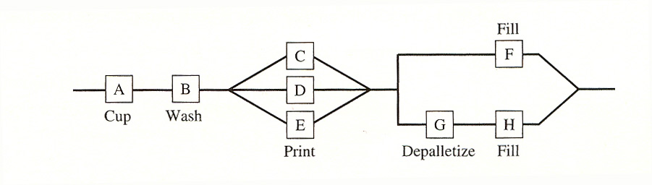
Ans:

